- Given the provided data, what are three conclusions that we can draw about crowdfunding campaigns?

Based on the crowdfunding campaign data show us that
- Theatre projects are 34 percent of the total applications submitted at the same time, which is 57% of the total successful project, 19% are for the theatre.
- When we subcategories the data, Plays dominate the projects which more the 30% of the projects.
- According to goals the data shows that the projects that have goals between 1000 to 4999 are the most successful projects and second to that are the ones that target from 5000 to 9999.Though, we do not have the reasons why this happened. The data shows us, these two goals are optimum target.

- What are some limitations of this dataset?
  - The variance is quite large, indicating a significant spread in the data, which could affect the reliability of the mean as a measure of central tendency. Therefore, the data is positive skewed since the mean is extremely greater than median,
- What are some other possible tables and/or graphs that we could create, and what additional value would they provide?
We can create table that summarizes the countries and the sum of pledged. And it shows that 73% of the pledged.

 | 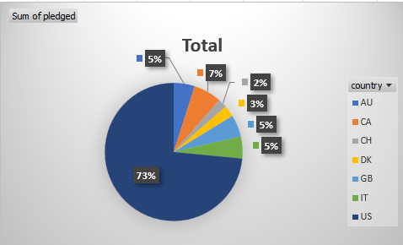
  Row Labels | Sum of pledged
  AU | 2114541
  CA | 2812788
  CH | 891415
  DK | 1129068
  GB | 2192705
  IT | 2198202
  US | 31409336
  Grand Total | 42748055

 | Successful | failed
The mean # of backers | 851 | 586
The median # of backers | 201 | 115
The minimum # of backers | 16 | 0
The maximum # of backers | 7295 | 6080
The variance of the # of backers | 1606217 | 924113
The standard deviation of the number of backers | 1267 | 961

- Use your data to determine whether the mean or the median better summarizes the data.
  - In this data, there are outliers or extreme value which are not giving us the actual central of tendency of the data. Therefore, we are using the median as its not effected by outliers. Hence, the median (201) has closer representation and summarizes better.

- Use your data to determine if there is more variability with successful or unsuccessful campaigns. Does this make sense? Why or why not?
  - There is more variability for successful data because,
    - Data collected itself as the sample size close to double.
    - the number of backers in each project are more in the successful sector as that determines the accomplishment of the project as well.
  - It makes sense that the variability of unsuccessful group to be less than half spread than the others. If we look as well the total sum of pledged is doubled for the success group

